- \Operation\IPC/bulkware ejection\Settings
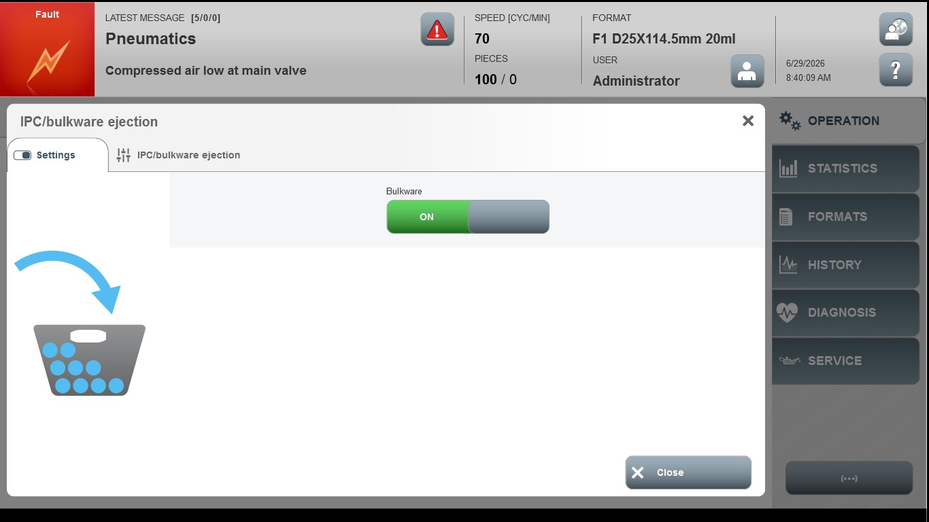
Acceptance criterion | Limits | Pass / Fail: Dev-No. | Date | Initials
Screen matches screenshot | N / A

